**CONFERENCE ROOM ARRANGEMENT**

**The Second International Conference on Green Technology and Sustainable Development 2014**

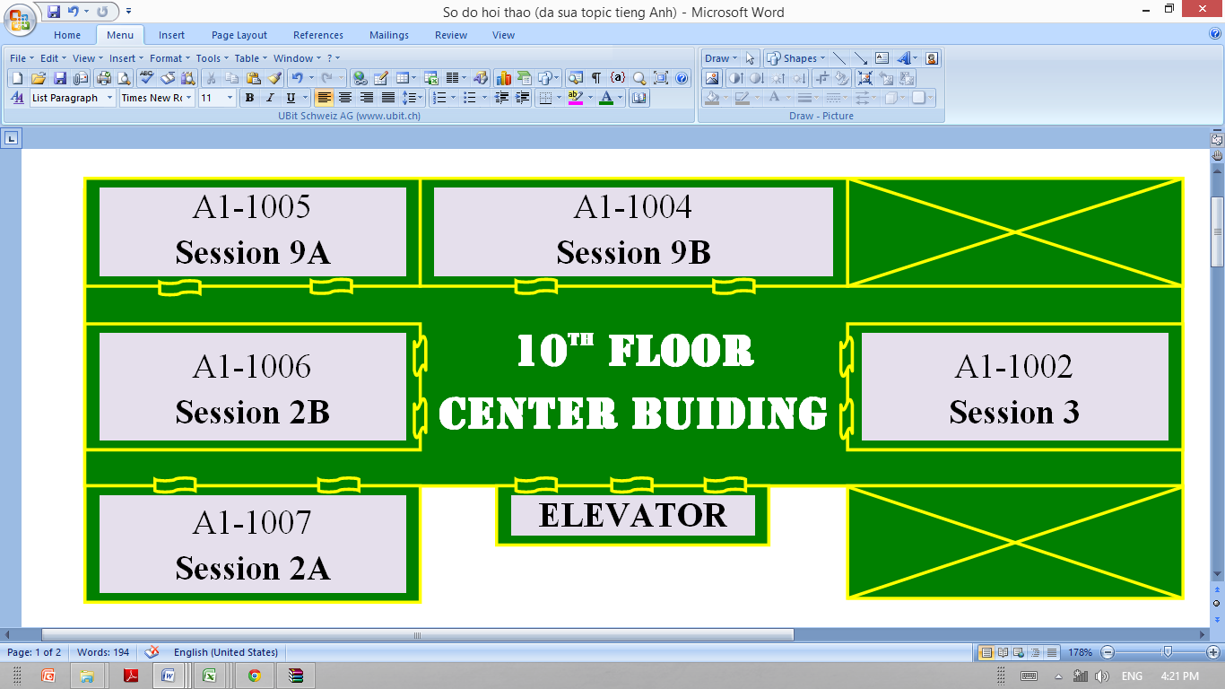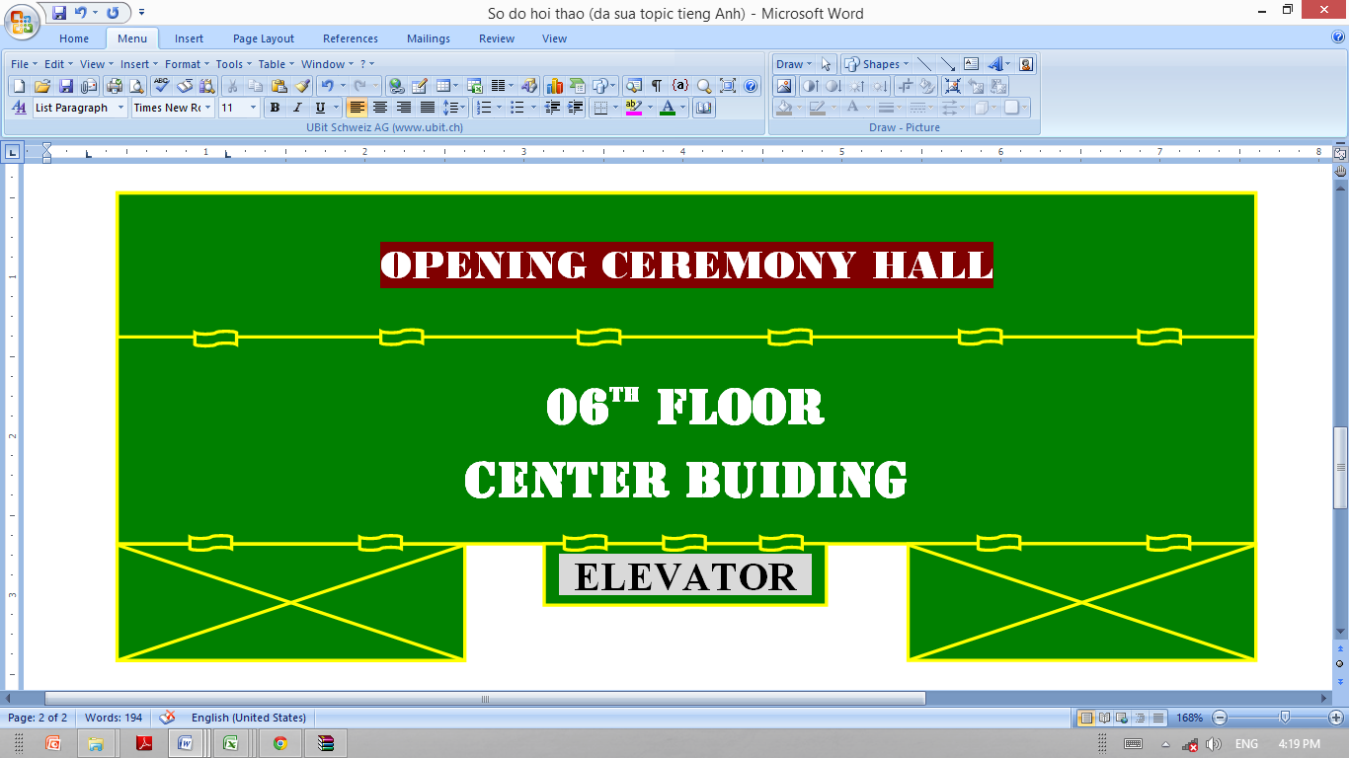

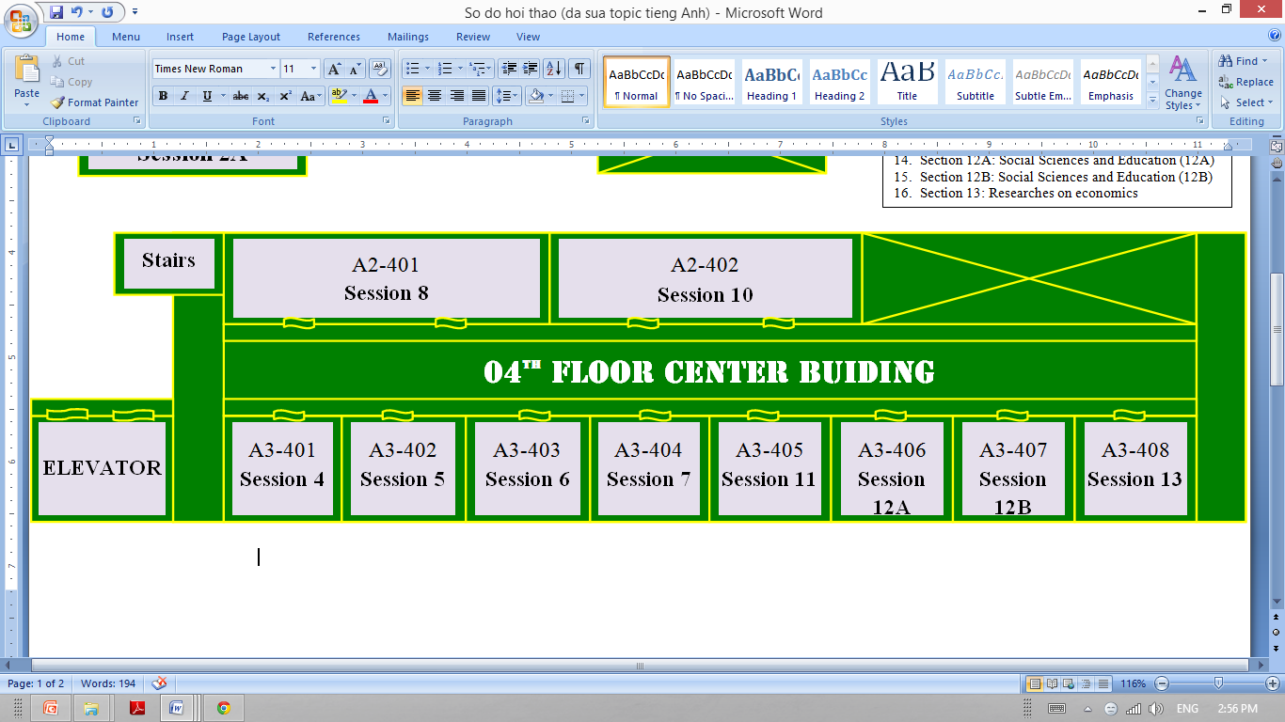

|  |  |
| --- | --- |
| ***NOTE:***   1. Session 1: Renewable Energy and Sustainable Development   **(*At* *the Opening Ceremony HALL)***   1. Session 2A: Mechanical Engineering (2A) 2. Session 2B: Mechanical Engineering (2B) 3. Session 3: Automotive and Thermal Engineering 4. Session 4: Electrical Engineering 5. Session 5: Telecommunication and Electronic Engineering 6. Session 6: Automatic Control Engineering | 1. Session 7: Information Technology 2. Session 8: Food Technology and Chemical Engineering 3. Session 9A: Construction Materials & Structures for Sustainable Development 4. Session 9B: Advanced Computations in Solid and Soil Mechanics 5. Session 10: Environmental Engineering 6. Session 11: Foundamential and Applied Sciences 7. Session 12A: Social Sciences and Education (12A) 8. Session 12B: Social Sciences and Education (12B) 9. Session 13: Subtainable Economics Development |